AGV Protocol – Tokenomics Document
Version 2.0 – Binance / VC Ready
Date: August 2025

1. Overview
AGV Protocol is a Real-World Asset (RWA) + DePIN tokenization framework that maps orchard yield, solar power, and compute nodes into verifiable on-chain assets.
The Tokenomics is designed for capital efficiency, market stability, and long-term yield alignment, ensuring balanced interests between asset providers, DAO governance, investors, and ecosystem growth.

2. Token Model

Core Tokens
GVT (Green Value Token)
Deterministic supply: 1,000,000,000 GVT
Minted via Power-to-Mint after IoT/oracle-confirmed productivity (kWh, kg harvest, compute cycles).
Utility: DAO governance, staking, asset adoption, DeFi integration, yield redemption.
rGGP (Rewarded Green Garden Points)
Variable supply (DAO budgeted annual emissions).
Earned via NFT adoption, staking, participation in DAO missions.
Convertible into GVT or used for ecosystem benefits (discounts, early access).

3. Supply & Allocation (GVT)
Category | Allocation | Vesting / Lock-up
Public Sale (NFT & Builder LP) | 20% | Unlock upon listing, subject to DEX/CEX liquidity schedule
DAO Treasury | 25% | Locked, DAO-governed disbursement
Asset Provider Rewards | 20% | Vested over verified yield period
Team & Advisors | 15% | 4-year vesting, 1-year cliff
Strategic Partnerships | 10% | 6–18 month vesting
Liquidity Provision & Market Making | 10% | Locked until MM contracts executed

4. Supply & Emission (rGGP)
Soft Annual Cap: Determined by DAO budget vote
Emission Curve: Decreases over 5 years to control inflation
Distribution Pathways: Airdrops, staking rewards, ecosystem bounties
Source Pool: DAO Treasury (media/marketing allocations come from here)

5. Utility & Value Accrual
Stake GVT → Earn verified rewards
Adopt NFTs → Unlock yield rights
DeFi Integration: LP farming, lending collateral, cross-chain swaps
Governance: DAO voting, proposal rights, treasury control
Revenue-Backed Buybacks: Treasury uses yield revenue to buy GVT in open market

6. Liquidity & Stability Strategy
Initial Liquidity: Allocated from Liquidity Provision & MM pool
Market Maker Agreements: 12–24 month contracts with Tier-1 MM firms
Price Stability Mechanisms: DAO-controlled buyback & burn, liquidity wall maintenance, emission throttling

7. Governance & Safeguards
Multi-sig Treasury: DAO Elected signers (min. 3 of 5)
Smart Contract Audit: Pre-listing audits by Tier-1 firm (CertiK, PeckShield)
Anti-Rug Protocol: All GVT allocations subject to DAO release approvals
Transparent On-chain Reporting: Real-time yield, token flows, DAO spending

8. Market Benchmarking
Project | Market Cap | FDV | Utility | Similarity
Ondo Finance | $1.2B | $1.6B | RWA fixed income | Partial
Power Ledger | $350M | $500M | Renewable energy tokenization | High
AGV Protocol | TBD | Target $80–150M FDV | Multi-asset RWA + DePIN | Unique

9. Investment Highlights
Real-Asset Backing: Every GVT minted corresponds to verified physical output.
Balanced Tokenomics: Fixed allocations for core stakeholders (Asset Provider 20%, Team 15%).
DAO Governance: Ensures transparency and community oversight of treasury.
Price Stability Strategy: Dedicated liquidity & MM pool with buyback mechanisms.
Multi-Asset Yield: Exposure to agriculture, renewable energy, and compute sectors in one token.

10. Token Allocation Diagram
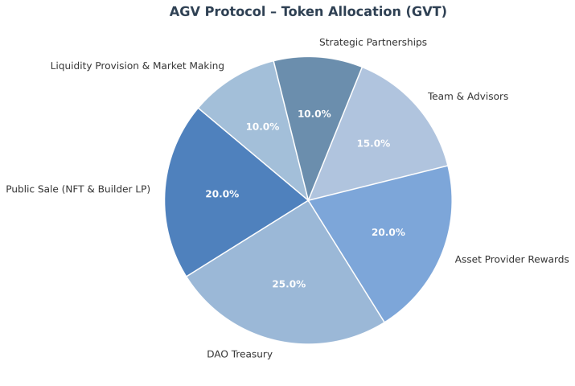

11. Vesting Schedule Chart
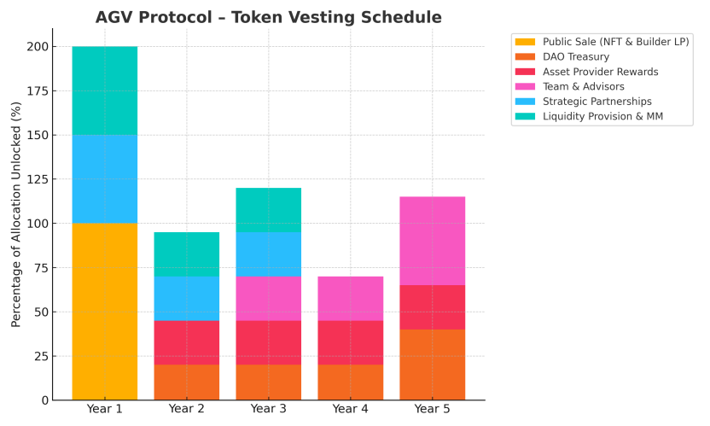

12. Legal & Compliance
Jurisdictions: Compliant with key markets (SG, JP, EU, NZ, HK)
SAFT Agreement: For pre-listing investors
KYC/AML: Mandatory for public sale participants
Regulatory Filings: Asset mapping contracts notarized and filed with relevant jurisdictions

Tokenomics Philosophy
"AGV Protocol’s token design is built to balance long-term asset yield with immediate investor incentives, ensuring sustainable growth without speculative inflation. Fixed core allocations protect asset providers and execution teams, while DAO-controlled treasury enables adaptive market strategies."
